5.41: a) Solving for D in terms of ,
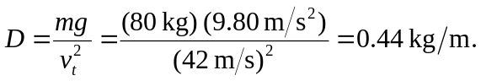
b) 